Web Service Investigator

Purpose: The WS Investigator enumerates all ALUI Web Service objects and ranks them by cache timeout to assist customers in performance tuning. The tool also provides a detailed summary for each Web Service configuration.

The current version of this utility was written as a Java swing application. This should allow the tool to be used on most (if not all) of the OS platforms upon which the AquaLogic User Interaction Portal is deployed.

The current version of this tool is an extension of the WS Investigator project designed by Raymond Gao. The version documented here was modified by Mike Sample for use by BID Customer Care.

Installation:

The tool is currently distributed as two jar files. Because it references several portal components, these files should be copied to the portal’s lib directory on a server hosting either an admin or end-user portal instance. An example of a typical location for the portal lib directory on a .NET deployment is:

C:\bea\alui\ptportal\6.1\lib\java

After copying the two jar files, swing-layout-1.0.jar and wsinvestigate.jar, to this directory, the utility can be launched by invoking the following command line arguments:

java –jar wsinvestigate.jar

The utility was built using the JDK corresponding to the same Java runtime version used by other portal components. To ensure the correct java runtime version, you may want to add a reference to your system path to the ALUI installed JRE (C:\bea\alui\jre1.4.2_06\bin) before launching the application.

Basic Use:

When the UI is first rendered, you must provide a portal user name and password. For obvious reasons it is preferable to use either the intrinsic administrator account or a user with comparable access to the portal’s admin objects. Once these credentials have been entered click on the “Run” button.

The initial session and query actions needed to build the Web Service list may take several seconds or even longer depending on the number of Web Service objects. Once complete, the utility should enumerate all of the Web Service objects in the upper left list box. A summary of the tool execution is printed out to the logging window beneath this.

The Web Service list is sorted in descending order by their “Cache Time”. This value is the minimum cache time configured in the Web Service editor. This presentation should allow the customer to quickly identify those Web Service objects which could benefit from better caching.

Once the Web Service list renders you can then select any individual Web Service to examine it in detail. Once a Web Service item is selected, the right hand list box will present configuration details particular to that object.

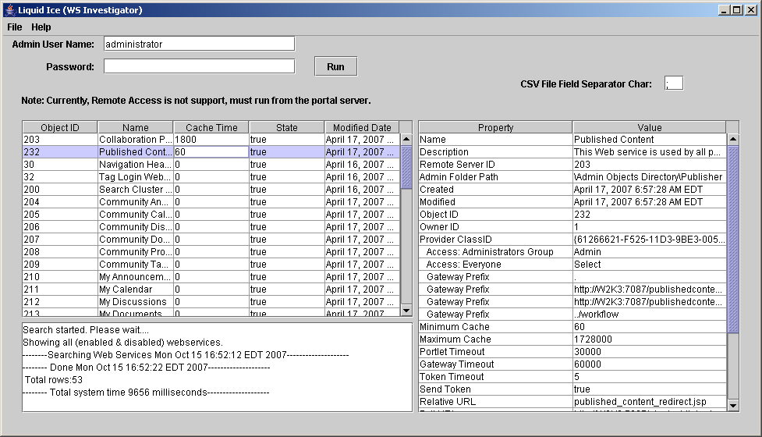

Among the details provided for each Web Service is a list of portlets and communities affected by its performance. This may be helpful in determining the impact of adjustments to the minimum cache timeout.

Finally, the tool can also generate a text file containing a delimited list of all the Web Services. The character used to delimit these items is taken from the “CSV File Field Separator Char” value at the top right of the tool.

